How to deploy Custom Service on bluemix

1. Create node.js project for providing Service broker definition and Service metadata
you can get our sample project by below project svn url: :https://issvn.innovate.ibm.com/svn/BRMS_PoC/SOE/STSPricing

  - Implement request interface for below path.
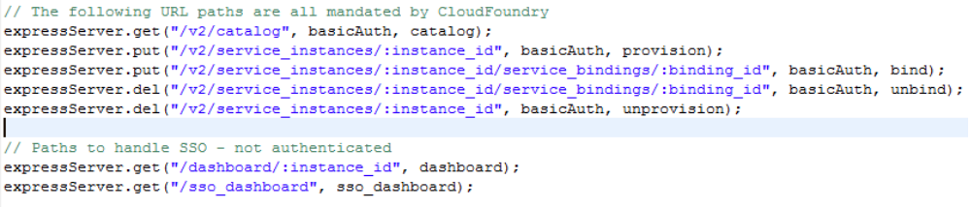
  - Set client id and user&password for service

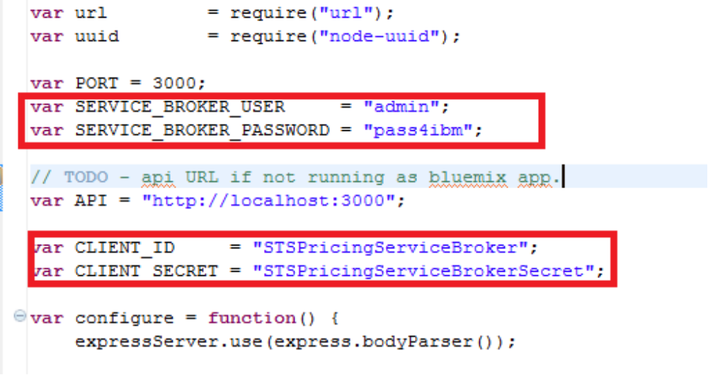
1.3 Set service id with uuid
you can get uuid from this site:http://www.guidgenerator.com/online-guid-generator.aspx

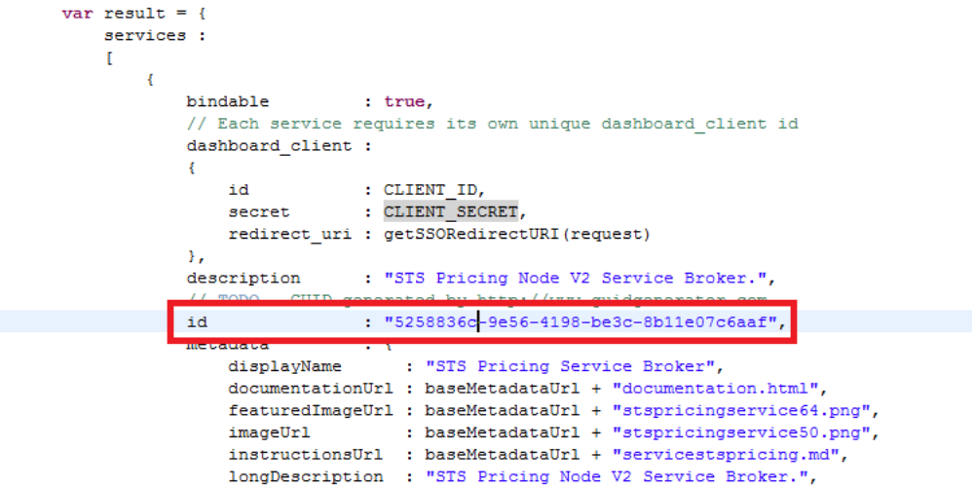
  - Set credentials information
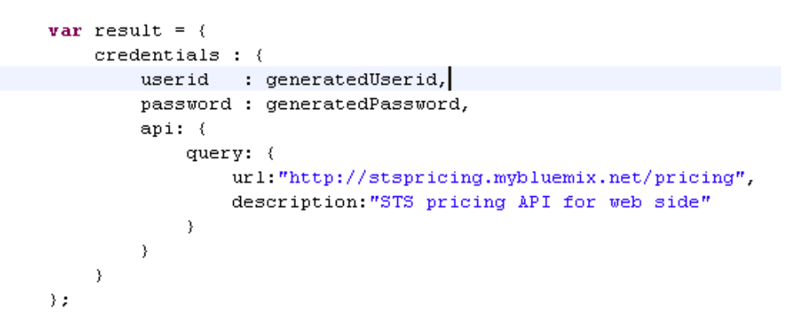
If need more detail about what 's the mean of these parameter, refer to below help document pls.
https://www.stage1.ng.bluemix.net/docs/#services/v2api.html#v2api

- Deploy node.js project on bluemix with cf command
Execute command: cf api https://api.ng.bluemix.net
Execute command: cf login username password
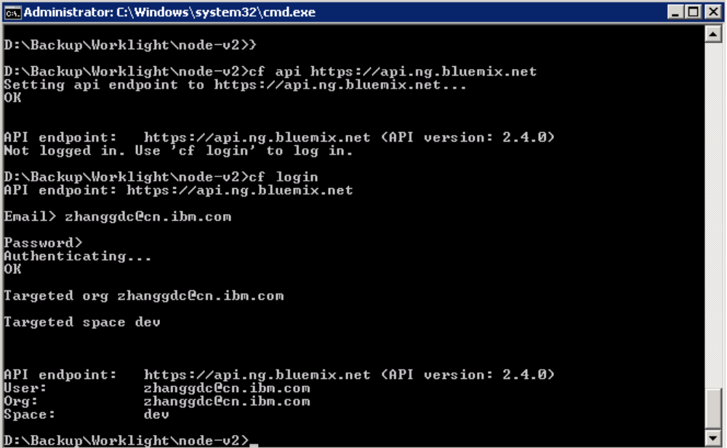
Execute command: cf push stspricing
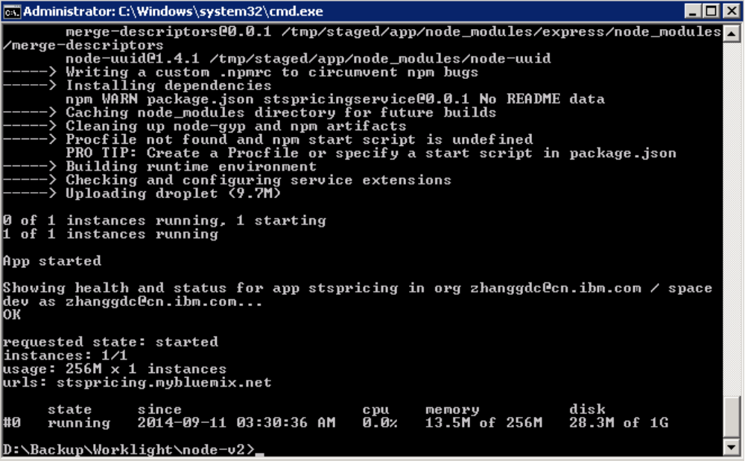

Access path “stspricing.mybluemix.net/v2/catalog” to check if app is right.

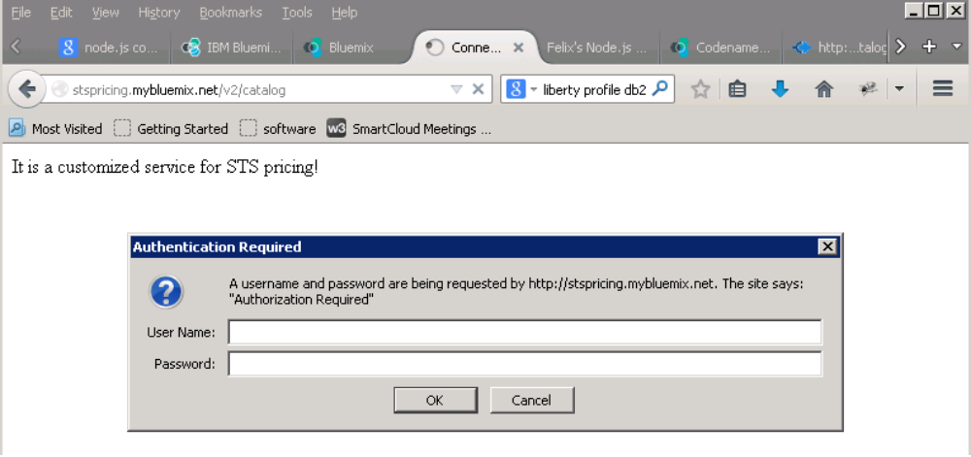

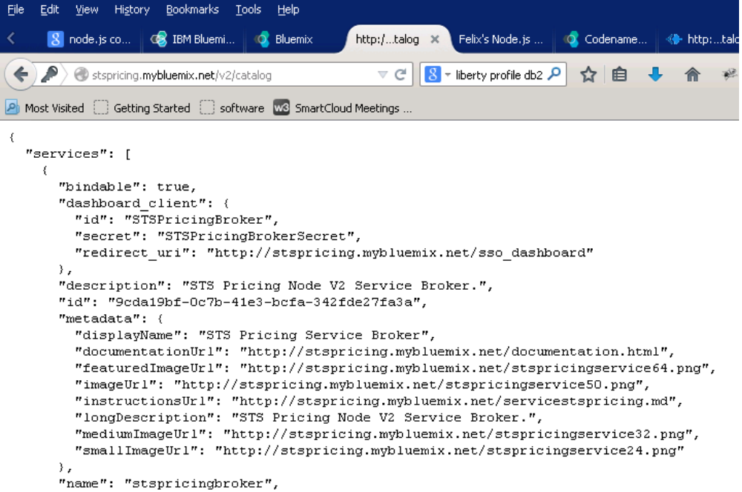
- Registering the service broker with the cloud-cli command line interface

  - Create json file for service broker included below content.
{
"name": "STSPricing",
"broker_url" : "http://stspricing.mybluemix.net",
"auth_username": "admin",
"auth_password": "pass4ibm",
"visibilities" : [
{"organization_name" : "zhanggdc@cn.ibm.com"}
]
}
  - Register with the cloud-cli command
Execute command:cloud-cli target http://ace.ng.bluemix.net
Execute command:cloud-cli login -userID username -pw password
Execute command: cloud-cli create-service-broker stspricing.json

- Check if custom service can be displayed on catalog page

